Lab - Troubleshooting Connectivity Issues
Topology
Addressing Table
Device | Interface | IP Address | Subnet Mask | Default Gateway
R1 | G0/1 | 192.168.1.1 | 255.255.255.0 | N/A
R1 | S0/0/0 | 10.1.1.1 | 255.255.255.252 | N/A
ISP | S0/0/0 | 10.1.1.2 | 255.255.255.252 | N/A
ISP | Lo0 | 209.165.200.226 | 255.255.255.255 | N/A
S1 | VLAN 1 | 192.168.1.2 | 255.255.255.0 | 192.168.1.1
PC-A | NIC | 192.168.1.10 | 255.255.255.0 | 192.168.1.1
Objectives
Part 1: Identify the Problem
Part 2: Implement Network Changes
Part 3: Verify Full Functionality
Part 4: Document Findings and Configuration Changes
Background / Scenario
In this lab, the company that you work for is experiencing problems with their Local Area Network (LAN). You have been asked to troubleshoot and resolve the network issues. In Part 1, you will connect to devices on the LAN and use troubleshooting tools to identify the network issues, establish a theory of probable cause, and test that theory. In Part 2, you will establish a plan of action to resolve and implement a solution. In Part 3, you will verify full functionality has been restored. Part 4 provides space for you to document your troubleshooting findings along with the configuration changes that you made to the LAN devices.
Note: The routers used with CCNA hands-on labs are Cisco 1941 Integrated Services Routers (ISRs) with Cisco IOS Release 15.2(4)M3 (universalk9 image). The switches used are Cisco Catalyst 2960s with Cisco IOS Release 15.0(2) (lanbasek9 image). Other routers, switches, and Cisco IOS versions may be used. Depending on the model and Cisco IOS version, the commands available and the output produced might vary from what is shown in the labs. Refer to the Router Interface Summary Table at the end of this lab for the correct interface identifiers.
Required Resources
- 2 Router (Cisco 1941 with Cisco IOS Release 15.2(4)M3 universal image or comparable)
- 1 Switch (Cisco 2960 with Cisco IOS Release 15.0(2) lanbasek9 image or comparable)
- 1 PC (Windows 7 or 8 with terminal emulation program, such as Tera Term)
- Ethernet and Serial cables as shown in the topology
Troubleshooting Configurations
The following settings must be configured on the devices shown in the topology. Paste the configurations onto the specified devices prior to starting the lab.
S1:
no ip domain-lookup
hostname S1
ip domain-name ccna-lab.com
username admin01 privilege 15 secret cisco12345
interface FastEthernet0/1
shutdown
interface FastEthernet0/2
shutdown
interface FastEthernet0/3
shutdown
interface FastEthernet0/4
shutdown
interface FastEthernet0/5
duplex full
interface Vlan1
ip address 192.168.1.2 255.255.255.0
line vty 0 4
login local
transport input ssh
line vty 5 15
login local
transport input ssh
crypto key generate rsa general-keys modulus 1024
end
R1:
hostname R1
no ip domain-lookup
ip domain-name ccna-lab.com
username admin01 privilege 15 secret cisco12345
interface GigabitEthernet0/0
shutdown
interface GigabitEthernet0/1
ip address 192.168.1.1 255.255.255.0
duplex half
speed auto
no shutdown
interface Serial0/0/0
ip address 10.1.2.1 255.255.255.252
no shutdown
interface Serial0/0/1
no ip address
shutdown
line vty 0 4
login local
transport input ssh
crypto key generate rsa general-keys modulus 1024
end
ISP:
hostname ISP
no ip domain-lookup
interface Serial0/0/0
ip address 10.1.1.2 255.255.255.252
no shut
interface Lo0
ip address 209.165.200.226 255.255.255.255
ip route 0.0.0.0 0.0.0.0 10.1.1.1
end
- Identify the Problem.
The only available information about the network problem is that the users are experiencing slow response times and that they are not able to reach an external device on the Internet at IP address 209.165.200.226. To determine probable cause(s) for these network issues, you will need to utilize network commands and tools on the LAN equipment shown in the topology.
Note: The user name admin01 with a password of cisco12345 will be required to log into the network equipment.
  - Troubleshoot from the PC.
    - From the PC command prompt, ping the external server IP Address 209.165.200.226.
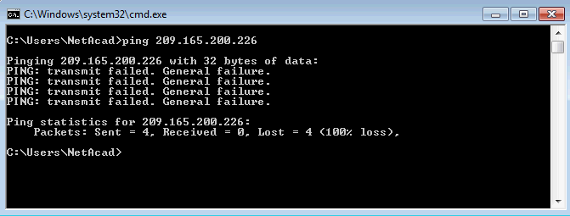
    - Use the ipconfig command to determine the network settings on the PC.
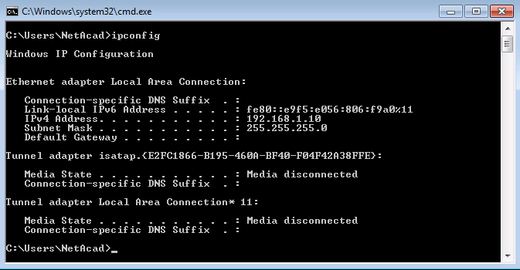
  - Troubleshoot from S1 using a SSH client session.
Note: Any SSH client software can be used. Tera Term is used in the examples in this lab.
    - SSH to S1 using its IP Address of 192.168.1.2 and log into the switch using admin01 for the user name and cisco12345 for the password.
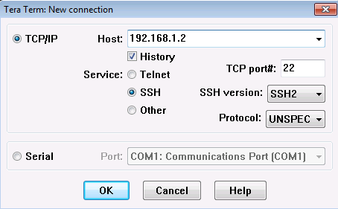
    - Issue the terminal monitor command on S1 to allow log messages to be sent to the VTY line of your SSH session. After a few seconds you notice the following error message being displayed in your SSH window.
S1# terminal monitor
S1#
*Mar 1 02:08:11.338: %CDP-4-DUPLEX_MISMATCH: duplex mismatch discovered on FastEthernet0/5 (not half duplex), with R1.ccna-lab.com GigabitEthernet0/1 (half duplex).
S1#
    - On S1, issue the show interface f0/5 command to view the duplex setting of the interface.
S1# show interface f0/5
FastEthernet0/5 is up, line protocol is up (connected)
Hardware is Fast Ethernet, address is 0cd9.96e8.8a05 (bia 0cd9.96e8.8a05)
MTU 1500 bytes, BW 100000 Kbit/sec, DLY 100 usec,
reliability 255/255, txload 1/255, rxload 1/255
Encapsulation ARPA, loopback not set
Keepalive set (10 sec)
Full-duplex, 100Mb/s, media type is 10/100BaseTX
input flow-control is off, output flow-control is unsupported
ARP type: ARPA, ARP Timeout 04:00:00
Last input 00:00:35, output 00:00:01, output hang never
Last clearing of "show interface" counters never
Input queue: 0/75/0/0 (size/max/drops/flushes); Total output drops: 0
Queueing strategy: fifo
Output queue: 0/40 (size/max)
5 minute input rate 0 bits/sec, 0 packets/sec
5 minute output rate 0 bits/sec, 0 packets/sec
849 packets input, 104642 bytes, 0 no buffer
Received 123 broadcasts (122 multicasts)
0 runts, 0 giants, 0 throttles
0 input errors, 0 CRC, 0 frame, 0 overrun, 0 ignored
0 watchdog, 122 multicast, 0 pause input
0 input packets with dribble condition detected
4489 packets output, 361270 bytes, 0 underruns
0 output errors, 0 collisions, 1 interface resets
0 unknown protocol drops
0 babbles, 0 late collision, 0 deferred
0 lost carrier, 0 no carrier, 0 pause output
0 output buffer failures, 0 output buffers swapped out
S1#
  - Troubleshoot on R1 using an SSH client.
    - SSH to R1’s LAN interface and log in using admin01 for the user name and cisco12345 as the password.
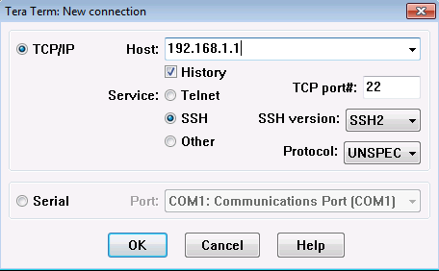
    - Issue the terminal monitor command on R1 to allow log messages to be sent to the VTY line of your SSH session for R1. After a few seconds the duplex mismatch message appears on R1’s SSH session.
R1# terminal monitor
R1#
*Nov 23 16:12:36.623: %CDP-4-DUPLEX_MISMATCH: duplex mismatch discovered on GigabitEthernet0/1 (not full duplex), with S1.ccna-lab.com FastEthernet0/5 (full duplex).
R1#
    - Issue the show interface G0/1 command on R1 to display the duplex setting.
R1# show interfaces g0/1
GigabitEthernet0/1 is up, line protocol is up
Hardware is CN Gigabit Ethernet, address is d48c.b5ce.a0c1 (bia d48c.b5ce.a0c1)
Internet address is 192.168.1.1/24
MTU 1500 bytes, BW 100000 Kbit/sec, DLY 100 usec,
reliability 255/255, txload 1/255, rxload 1/255
Encapsulation ARPA, loopback not set
Keepalive set (10 sec)
Half Duplex, 100Mbps, media type is RJ45
output flow-control is unsupported, input flow-control is unsupported
ARP type: ARPA, ARP Timeout 04:00:00
Last input 00:00:15, output 00:00:05, output hang never
Last clearing of "show interface" counters never
Input queue: 0/75/0/0 (size/max/drops/flushes); Total output drops: 0
Queueing strategy: fifo
Output queue: 0/40 (size/max)
5 minute input rate 0 bits/sec, 0 packets/sec
5 minute output rate 0 bits/sec, 0 packets/sec
641 packets input, 101892 bytes, 0 no buffer
Received 453 broadcasts (0 IP multicasts)
0 runts, 0 giants, 0 throttles
0 input errors, 0 CRC, 0 frame, 0 overrun, 0 ignored
0 watchdog, 361 multicast, 0 pause input
1043 packets output, 123698 bytes, 0 underruns
0 output errors, 0 collisions, 1 interface resets
235 unknown protocol drops
0 babbles, 0 late collision, 0 deferred
0 lost carrier, 0 no carrier, 0 pause output
0 output buffer failures, 0 output buffers swapped out
R1#
    - Issue the ping 209.165.200.226 command on R1 to test connectivity to the external server.
R1# ping 209.165.200.226
Type escape sequence to abort.
Sending 5, 100-byte ICMP Echos to 209.165.200.226, timeout is 2 seconds:
.....
Success rate is 0 percent (0/5)
R1#
    - Issue the show ip interface brief command on R1 to verify interface IP Address settings.
R1# show ip interface brief
Interface IP-Address OK? Method Status Protocol
Embedded-Service-Engine0/0 unassigned YES unset administratively down down
GigabitEthernet0/0 unassigned YES unset administratively down down
GigabitEthernet0/1 192.168.1.1 YES manual up up
Serial0/0/0 10.1.2.1 YES manual up up
Serial0/0/1 unassigned YES unset administratively down down
R1#
    - Issue the show ip route command on R1 to verify the router’s default gateway setting.
R1# show ip route
Codes: L - local, C - connected, S - static, R - RIP, M - mobile, B - BGP
D - EIGRP, EX - EIGRP external, O - OSPF, IA - OSPF inter area
N1 - OSPF NSSA external type 1, N2 - OSPF NSSA external type 2
E1 - OSPF external type 1, E2 - OSPF external type 2
i - IS-IS, su - IS-IS summary, L1 - IS-IS level-1, L2 - IS-IS level-2
ia - IS-IS inter area, * - candidate default, U - per-user static route
o - ODR, P - periodic downloaded static route, H - NHRP, l - LISP
a - application route
+ - replicated route, % - next hop override

Gateway of last resort is not set

10.0.0.0/8 is variably subnetted, 2 subnets, 2 masks
C 10.1.2.0/30 is directly connected, Serial0/0/0
L 10.1.2.1/32 is directly connected, Serial0/0/0
192.168.1.0/24 is variably subnetted, 2 subnets, 2 masks
C 192.168.1.0/24 is directly connected, GigabitEthernet0/1
L 192.168.1.1/32 is directly connected, GigabitEthernet0/1
R1#
List the probable causes for the network problems that employees are experiencing.
____________________________________________________________________________________
____________________________________________________________________________________
____________________________________________________________________________________
____________________________________________________________________________________
- Implement Network Changes
You have communicated the problems that you discovered in Part 1 to your supervisor. She has approved these changes and has requested that you implement them.
  - Set the Default Gateway on the PC to 192.168.1.1.
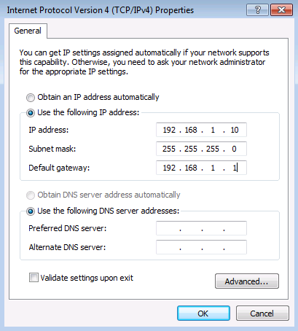
  - Set the duplex setting for interface G0/1 on R1 to full duplex.
R1# conf t
Enter configuration commands, one per line. End with CNTL/Z.
R1(config)#
*Nov 23 17:23:36.879: %CDP-4-DUPLEX_MISMATCH: duplex mismatch discovered on GigabitEthernet0/1 (not full duplex), with S1.ccna-lab.com FastEthernet0/5 (full duplex).
R1(config)#
R1(config)# interface g0/1
R1(config-if)# duplex full
R1(config-if)# exit
*Nov 23 17:24:08.039: %LINK-3-UPDOWN: Interface GigabitEthernet0/1, changed state to down
R1(config)#
*Nov 23 17:24:10.363: %LINK-3-UPDOWN: Interface GigabitEthernet0/1, changed state to up
*Nov 23 17:24:10.459: %SYS-5-CONFIG_I: Configured from console by console
R1(config)#
  - Reconfigure the IP address for S0/0/0 to IP Address 10.1.1.1/30 on R1.
R1(config)# interface s0/0/0
R1(config-if)# ip address 10.1.1.1 255.255.255.252
R1(config-if)# exit
  - Configure the Gateway of last resort on R1 with a 10.1.1.2 default route.
R1(config)# ip route 0.0.0.0 0.0.0.0 10.1.1.2
R1(config)# end
- Verify Full Functionality
Verify that full functionality has been restored.
  - Verify that all interfaces and routes have been set correctly and that routing has been restored on R1.
    - Issue the show ip route command to verify that the default gateway has been set correctly.
R1# show ip route
Codes: L - local, C - connected, S - static, R - RIP, M - mobile, B - BGP
D - EIGRP, EX - EIGRP external, O - OSPF, IA - OSPF inter area
N1 - OSPF NSSA external type 1, N2 - OSPF NSSA external type 2
E1 - OSPF external type 1, E2 - OSPF external type 2
i - IS-IS, su - IS-IS summary, L1 - IS-IS level-1, L2 - IS-IS level-2
ia - IS-IS inter area, * - candidate default, U - per-user static route
o - ODR, P - periodic downloaded static route, H - NHRP, l - LISP
a - application route
+ - replicated route, % - next hop override

Gateway of last resort is 10.1.1.2 to network 0.0.0.0

S* 0.0.0.0/0 [1/0] via 10.1.1.2
10.0.0.0/8 is variably subnetted, 2 subnets, 2 masks
C 10.1.1.0/30 is directly connected, Serial0/0/0
L 10.1.1.1/32 is directly connected, Serial0/0/0
192.168.1.0/24 is variably subnetted, 2 subnets, 2 masks
C 192.168.1.0/24 is directly connected, GigabitEthernet0/1
L 192.168.1.1/32 is directly connected, GigabitEthernet0/1
R1#
    - Issue the show ip interface s0/0/0 command to verify that the IP Address on S0/0/0 is set correctly.
R1# show ip interface s0/0/0
Serial0/0/0 is up, line protocol is up
Internet address is 10.1.1.1/30
Broadcast address is 255.255.255.255
Address determined by setup command
MTU is 1500 bytes
<output omitted>
IPv4 WCCP Redirect exclude is disabled
R1#
    - Issue the ping 209.165.200.226 command to verify that the external server is reachable now.
R1# ping 209.165.200.226
Type escape sequence to abort.
Sending 5, 100-byte ICMP Echos to 209.165.200.226, timeout is 2 seconds:
!!!!!
Success rate is 100 percent (5/5), round-trip min/avg/max = 1/2/4 ms
R1#
    - Issue the show interface g0/1 command to verify that the duplex setting is full duplex.
R1# show interface g0/1
GigabitEthernet0/1 is up, line protocol is up
Hardware is CN Gigabit Ethernet, address is d48c.b5ce.a0c1 (bia d48c.b5ce.a0c1)
Internet address is 192.168.1.1/24
MTU 1500 bytes, BW 100000 Kbit/sec, DLY 100 usec,
reliability 255/255, txload 1/255, rxload 1/255
Encapsulation ARPA, loopback not set
Keepalive set (10 sec)
Full Duplex, 100Mbps, media type is RJ45
output flow-control is unsupported, input flow-control is unsupported
ARP type: ARPA, ARP Timeout 04:00:00
Last input 00:00:04, output 00:00:04, output hang never
Last clearing of "show interface" counters never
Input queue: 0/75/0/0 (size/max/drops/flushes); Total output drops: 0
Queueing strategy: fifo
Output queue: 0/40 (size/max)
5 minute input rate 0 bits/sec, 0 packets/sec
5 minute output rate 0 bits/sec, 0 packets/sec
559 packets input, 74066 bytes, 0 no buffer
Received 279 broadcasts (0 IP multicasts)
0 runts, 0 giants, 0 throttles
0 input errors, 0 CRC, 0 frame, 0 overrun, 0 ignored
0 watchdog, 208 multicast, 0 pause input
742 packets output, 81462 bytes, 0 underruns
0 output errors, 0 collisions, 2 interface resets
133 unknown protocol drops
0 babbles, 0 late collision, 0 deferred
1 lost carrier, 0 no carrier, 0 pause output
0 output buffer failures, 0 output buffers swapped out
R1#
  - Verify End-to-End connectivity from the LAN PC.
    - Issue the ipconfig command from the command prompt on the PC.
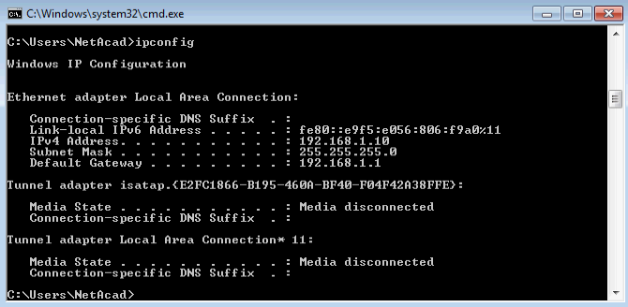
    - Issue the ping 209.165.200.226 command from the CMD window on the PC
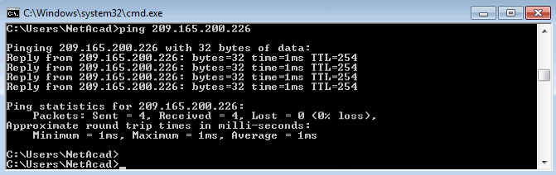
- Document Findings and Configuration Changes
Use the space provided below to document the issues found during your troubleshooting and the configurations changes made to resolve those issues.
_______________________________________________________________________________________
_______________________________________________________________________________________
_______________________________________________________________________________________
_______________________________________________________________________________________
_______________________________________________________________________________________
_______________________________________________________________________________________
_______________________________________________________________________________________
_______________________________________________________________________________________
_______________________________________________________________________________________
_______________________________________________________________________________________
_______________________________________________________________________________________
_______________________________________________________________________________________
_______________________________________________________________________________________
_______________________________________________________________________________________
_______________________________________________________________________________________
_______________________________________________________________________________________
_______________________________________________________________________________________
_______________________________________________________________________________________
_______________________________________________________________________________________
_______________________________________________________________________________________
Reflection
This lab had you troubleshoot all devices before making any changes. Is there another way to apply the troubleshooting methodology?
_______________________________________________________________________________________
_______________________________________________________________________________________
_______________________________________________________________________________________
_______________________________________________________________________________________
_______________________________________________________________________________________
_______________________________________________________________________________________
_______________________________________________________________________________________
Router Interface Summary Table
Router Interface Summary
Router Model | Ethernet Interface #1 | Ethernet Interface #2 | Serial Interface #1 | Serial Interface #2
1800 | Fast Ethernet 0/0 (F0/0) | Fast Ethernet 0/1 (F0/1) | Serial 0/0/0 (S0/0/0) | Serial 0/0/1 (S0/0/1)
1900 | Gigabit Ethernet 0/0 (G0/0) | Gigabit Ethernet 0/1 (G0/1) | Serial 0/0/0 (S0/0/0) | Serial 0/0/1 (S0/0/1)
2801 | Fast Ethernet 0/0 (F0/0) | Fast Ethernet 0/1 (F0/1) | Serial 0/1/0 (S0/1/0) | Serial 0/1/1 (S0/1/1)
2811 | Fast Ethernet 0/0 (F0/0) | Fast Ethernet 0/1 (F0/1) | Serial 0/0/0 (S0/0/0) | Serial 0/0/1 (S0/0/1)
2900 | Gigabit Ethernet 0/0 (G0/0) | Gigabit Ethernet 0/1 (G0/1) | Serial 0/0/0 (S0/0/0) | Serial 0/0/1 (S0/0/1)
Note: To find out how the router is configured, look at the interfaces to identify the type of router and how many interfaces the router has. There is no way to effectively list all the combinations of configurations for each router class. This table includes identifiers for the possible combinations of Ethernet and Serial interfaces in the device. The table does not include any other type of interface, even though a specific router may contain one. An example of this might be an ISDN BRI interface. The string in parenthesis is the legal abbreviation that can be used in Cisco IOS commands to represent the interface.

